**CACEO 2015 CONFERENCE**

**GOLF OUTING**

Tuesday, July 14, 2015

Foxtail Golf Club – North Course

100 Golf Course Drive –Rohnert Park

[www.playfoxtail.com](http://www.playfoxtail.com/)

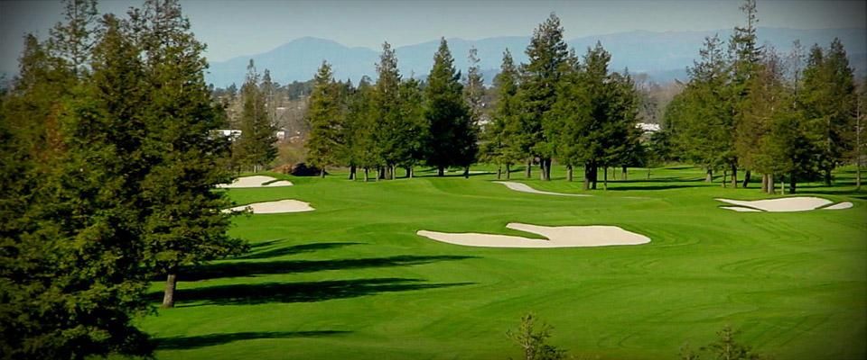

* First Tee Time: 11:00am (we will be done by early afternoon).
* Price: $50.
* Includes: Green fee & Cart fee, plus…

**Beautiful course with lots of trees and lakes to take in the beautiful scenery located just adjacent to the hotel grounds of the Double Tree Hotel!**

Join your CACEO compadres for a few hours of golfing fun and comradery!



|  |  |  |  |
| --- | --- | --- | --- |
| Name____________________________________ | | Email Address ____________________________ | |
| County/Company____________________________ | | Contact Number (cell) ___________________ | |
| Handicap/Average Score ______________ Requested Players_______________________________ | | | |
| Mail registration with check made payable to Greg Walsh (no credit cards), by June 17, 2015  to: | | | |
| **Greg Walsh, 585 Fiscal Dr. Rm 104-Santa Rosa, CA 95403** | | | |
| work phone: 707-565-1861 |  | |  |

email:greg.walsh@sonoma-county.org